Introduction
From: https://www.govinfo.gov/app/details/FR-2018-12-11/R1-2018-26365
Note: On the Federal Register page above, I clicked PDF and downloaded "R1-2018-26365.pdf". I opened that with Word 2013 and saved it as
20181226 R1-2018-26365 New 'Runaway Stabilizer' AD for Model 737–8 and –9.docx.
This will include pages 63561 through 63565 of the Federal Register.
The parts in dark gray are irrelevant; they preceed or follow the item of interest!

63561
Federal Register /Vol. 83, No. 237 /Tuesday, December 11, 2018 /Rules and Regulations 63561
more engines, loss of thrust control, and loss of the airplane.
(f) Compliance
Comply with this AD within the compliance times specified, unless already done.
(g) Required Actions
Within 60 days after the effective date of this AD, remove electronic engine control (EEC) system operation (OPS) software, P/N 2628M86P10 or earlier; and engine health monitoring (EHM) software, P/N 2628M87P10 or earlier, from the engine and from service.
Before further flight after the removal of the EEC OPS and EHM software required by paragraph (g)(1) of this AD, install EEC OPS and EHM software that is eligible for installation.
(h) Installation Prohibition
After 60 days from the effective date of this AD, do not operate any engine identified in paragraph (c) of this AD with EEC OPS software, P/N 2628M86P10 or earlier, installed; or EHM software, P/N 2628M87P10 or earlier, installed.
(i) Alternative Methods of Compliance (AMOCs)
The Manager, ECO Branch, FAA, has the authority to approve AMOCs for this AD, if requested using the procedures found in 14 CFR 39.19. In accordance with 14 CFR 39.19, send your request to your principal inspector or local Flight Standards District Office, as appropriate. If sending information directly to the manager of the certification office, send it to the attention of the person identified in paragraph (j) of this AD. You may email your request to: ANE-AD-AMOC@ faa.gov.
Before using any approved AMOC, notify your appropriate principal inspector, or lacking a principal inspector, the manager of the local flight standards district office/ certificate holding district office.
(j) Related Information
For more information about this AD, contact Christopher McGuire, Aerospace Engineer, ECO Branch, FAA, 1200 District
Avenue, Burlington, MA 01803; phone: 781– 238–7120; fax: 781–238–7199; email: chris.mcguire@faa.gov.
(k) Material Incorporated by Reference None.
Issued in Burlington, Massachusetts, on December 3, 2018.
Robert J. Ganley,
Manager, Engine and Propeller Standards Branch, Aircraft Certification Service.
[FR Doc. 2018–26611 Filed 12–10–18; 8:45 am]
BILLING CODE 4910–13–P
DEPARTMENT OF TRANSPORTATION

Federal Aviation Administration

14 CFR Part 39
[Docket No. FAA–2018–0960; Product
Identifier 2018–NM–151–AD; Amendment
39–19512; AD 2018–23–51]
RIN 2120–AA64

Airworthiness Directives; The Boeing Company Airplanes
Editorial Note: Rule document 2018–26365 was originally published on pages 62697 through 62700 in the issue of Thursday, December 6, 2018. In that publication, on page 62700, in Figure 2 to paragraph (h), the last sentence in the table was inadvertently truncated. The corrected document is published here in its entirety.
AGENCY: Federal Aviation Administration (FAA), DOT.
ACTION: Final rule; request for comments.

SUMMARY: We are adopting a new airworthiness directive (AD) for all The Boeing Company Model 737–8 and –9 airplanes. This emergency AD was sent previously to all known U.S. owners and operators of these airplanes. This AD requires revising certificate limitations and operating procedures of the airplane flight manual (AFM) to provide the flight crew with runaway horizontal stabilizer trim procedures to follow under certain conditions. This AD was prompted by analysis performed by the manufacturer showing that if an erroneously high single angle of attack (AOA) sensor input is received by the flight control system, there is a potential for repeated nose-down trim commands of the horizontal stabilizer. We are issuing this AD to address the unsafe condition on these products.
DATES: This AD is effective December 21, 2018 to all persons except those persons to whom it was made immediately effective by Emergency AD 2018–23–51, issued on November 7, 2018, which contained the requirements of this amendment. We must receive comments on this AD by January 22, 2019.
ADDRESSES: You may send comments, using the procedures found in 14 CFR 11.43 and 11.45, by any of the following methods:
- Federal eRulemaking Portal: Go to http://www.regulations.gov. Follow the instructions for submitting comments.
- Fax: 202–493–2251.
- Mail: U.S. Department of Transportation, Docket Operations, M–30, West Building Ground Floor, Room W12–140, 1200 New Jersey Avenue SE, Washington, DC 20590.
Frm 00003
- Hand Delivery: Deliver to Mail address above between 9 a.m. and 5
p.m., Monday through Friday, except Federal holidays.

Examining the AD Docket
You may examine the AD docket on the internet at http:// www.regulations.gov by searching for and locating Docket No. FAA–2018– 0960; or in person at Docket Operations between 9 a.m. and 5 p.m., Monday through Friday, except Federal holidays.
The AD docket contains this final rule, the regulatory evaluation, any comments received, and other information. The street address for Docket Operations (phone: 800–647– 5527) is in the ADDRESSES section. Comments will be available in the AD docket shortly after receipt.
FOR FURTHER INFORMATION CONTACT: Douglas Tsuji, Senior Aerospace
Engineer, Systems and Equipment
Section, FAA, Seattle ACO Branch, 2200 South 216th St., Des Moines, WA 98198; phone and fax: 206–231–3548; email: Douglas.Tsuji@faa.gov.
SUPPLEMENTARY INFORMATION:

Discussion
On November 7, 2018, we issued Emergency AD 2018–23–51, which requires revising certificate limitations and operating procedures of the AFM to provide the flight crew with runaway horizontal stabilizer trim procedures to follow under certain conditions. This emergency AD was sent previously to all known U.S. owners and operators of these airplanes. This action was prompted by analysis performed by the manufacturer showing that if an erroneously high single AOA sensor input is received by the flight control system, there is a potential for repeated nose-down trim commands of the horizontal stabilizer. This condition, if not addressed, could cause the flight crew to have difficulty controlling the airplane, and lead to excessive nose- down attitude, significant altitude loss, and possible impact with terrain.

FAA’s Determination
We are issuing this AD because we evaluated all the relevant information and determined the unsafe condition described previously is likely to exist or develop in other products of the same type design. [And indeed, it did.]

AD Requirements
This AD requires revising certificate limitations and operating procedures of the AFM to provide the flight crew with runaway horizontal stabilizer trim procedures to follow under certain conditions.

63562
63562 Federal Register / Vol. 83, No. 237 / Tuesday, December 11, 2018 / Rules and Regulations

Interim Action
We consider this AD interim action. If final action is later identified, we might consider further rulemaking then.

FAA’s Determination of the Effective Date
An unsafe condition exists that requires the immediate adoption of Emergency AD 2018–23–51, issued on November 7, 2018, to all known U.S. owners and operators of these airplanes. The FAA found that the risk to the flying public justified waiving notice and comment prior to adoption of this rule because an erroneously high single AOA sensor input received by the flight control system can result in a potential for repeated nose-down trim commands of the horizontal stabilizer, which could cause the flight crew to have difficulty controlling the airplane, and lead to excessive nose-down attitude, significant altitude loss, and possible impact with terrain. These conditions still exist and the AD is hereby published in the Federal Register as an amendment to section 39.13 of the
Federal Aviation Regulations (14 CFR
39.13) to make it effective to all persons.
Therefore, we find good cause that notice and opportunity for prior public comment are impracticable. In addition, for the reason(s) stated above, we find that good cause exists for making this amendment effective in less than 30 days.

Comments Invited
This AD is a final rule that involves requirements affecting flight safety and was not preceded by notice and an opportunity for public comment. However, we invite you to send any written data, views, or arguments about this final rule. Send your comments to an address listed under the ADDRESSES section. Include the docket number FAA–2018–0960 and Product Identifier 2018–NM–151–AD at the beginning of your comments. We specifically invite comments on the overall regulatory, economic, environmental, and energy aspects of this final rule. We will consider all comments received by the closing date and may amend this final rule because of those comments.
We will post all comments we receive, without change, to http:// www.regulations.gov, including any personal information you provide. We will also post a report summarizing each substantive verbal contact we receive about this final rule.

Costs of Compliance
We estimate that this AD affects 45 airplanes of U.S. registry. We estimate the following costs to comply with this AD:

ESTIMATED COSTS FOR REQUIRED ACTIONS
Action | Labor cost | Parts cost | Cost per product | Cost on U.S. operators
Revising the AFM ........................................... | 1 work-hour × $85 per hour = $85 ................. | $0 | $85 | $3,825

Authority for This Rulemaking
Title 49 of the United States Code specifies the FAA’s authority to issue rules on aviation safety. Subtitle I, section 106, describes the authority of the FAA Administrator. ‘‘Subtitle VII: Aviation Programs’’ describes in more detail the scope of the Agency’s authority.
We are issuing this rulemaking under the authority described in Subtitle VII, Part A, Subpart III, Section 44701: ‘‘General requirements.’’ Under that section, Congress charges the FAA with promoting safe flight of civil aircraft in air commerce by prescribing regulations for practices, methods, and procedures the Administrator finds necessary for safety in air commerce. This regulation is within the scope of that authority because it addresses an unsafe condition that is likely to exist or develop on products identified in this rulemaking action.
This AD is issued in accordance with authority delegated by the Executive Director, Aircraft Certification Service, as authorized by FAA Order 8000.51C. In accordance with that order, issuance of ADs is normally a function of the Compliance and Airworthiness Division, but during this transition period, the Executive Director has delegated the authority to issue ADs applicable to transport category airplanes and associated appliances to the Director of the System Oversight Division.

Regulatory Findings
This AD will not have federalism implications under Executive Order 13132. This AD will not have a substantial direct effect on the States, on the relationship between the national government and the States, or on the distribution of power and responsibilities among the various levels of government.
For the reasons discussed above, I certify that this AD:
- Is not a ‘‘significant regulatory action’’ under Executive Order 12866,
- Is not a ‘‘significant rule’’ under
DOT Regulatory Policies and Procedures
(44 FR 11034, February 26, 1979),
- Will not affect intrastate aviation in Alaska, and
- Will not have a significant economic impact, positive or negative, on a substantial number of small entities under the criteria of the Regulatory Flexibility Act.

List of Subjects in 14 CFR Part 39
Air transportation, Aircraft, Aviation safety, Incorporation by reference, Safety.

Adoption of the Amendment
Accordingly, under the authority delegated to me by the Administrator,
Frm 00004
the FAA amends 14 CFR part 39 as follows:

PART 39—AIRWORTHINESS DIRECTIVES
■ 1. The authority citation for part 39 continues to read as follows:
Authority: 49 U.S.C. 106(g), 40113, 44701.
§39.13 [Amended]
■ 2. The FAA amends §39.13 by adding the following new airworthiness directive (AD):
2018–23–51 The Boeing Company:
Amendment 39–19512; Docket No. FAA–2018–0960; Product Identifier 2018–NM–151–AD.

(a) Effective Date
This AD is effective December 21, 2018 to all persons except those persons to whom it was made immediately effective by Emergency AD 2018–23–51, issued on November 7, 2018, which contained the requirements of this amendment.
(b) Affected ADs None.

(c) Applicability
This AD applies to all The Boeing Company Model 737–8 and –9 airplanes, certificated in any category.

(d) Subject
Air Transport Association (ATA) of America Code 27, Flight controls.

63563
Federal Register /Vol. 83, No. 237 /Tuesday, December 11, 2018 /Rules and Regulations 63563

(e) Unsafe Condition
This AD was prompted by analysis performed by the manufacturer [After the LionAir disaster in Oct 2018] showing that if an erroneously high single angle of attack (AOA) sensor input is received by the flight control system, there is a potential for repeated nose-down trim commands of the horizontal stabilizer. We are issuing this AD to address this potential resulting nose-down trim, which could cause the flight crew to have difficulty controlling the airplane, and lead to excessive nose-down attitude, significant altitude loss, and possible impact with terrain.

(f) Compliance
Comply with this AD within the compliance times specified, unless already done.

(g) Revision of Airplane Flight Manual (AFM): Certificate Limitations
Within 3 days after the effective date of this AD, revise the Certificate Limitations chapter of the applicable AFM to include the information in figure 1 to paragraph (g) of this AD.
BILLING CODE 1301–00–D

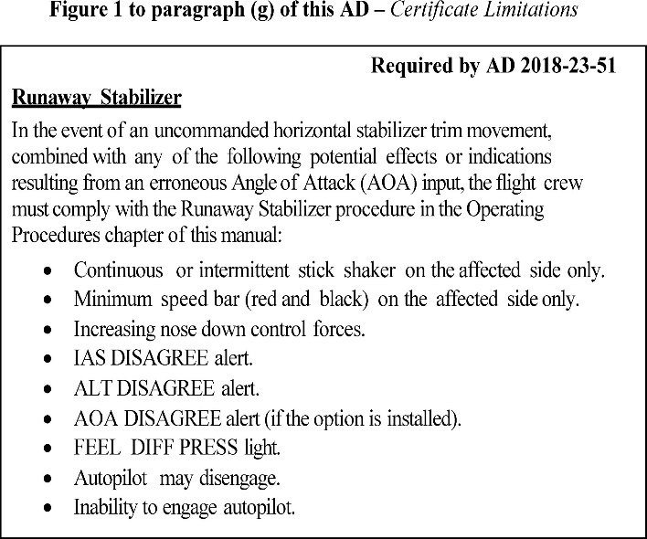
zz

(h) AFM Revision: Operating Procedures
Within 3 days after the effective date of this AD, revise the Operating Procedures chapter of the applicable AFM to include the information in figure 2 to paragraph (h) of this AD.
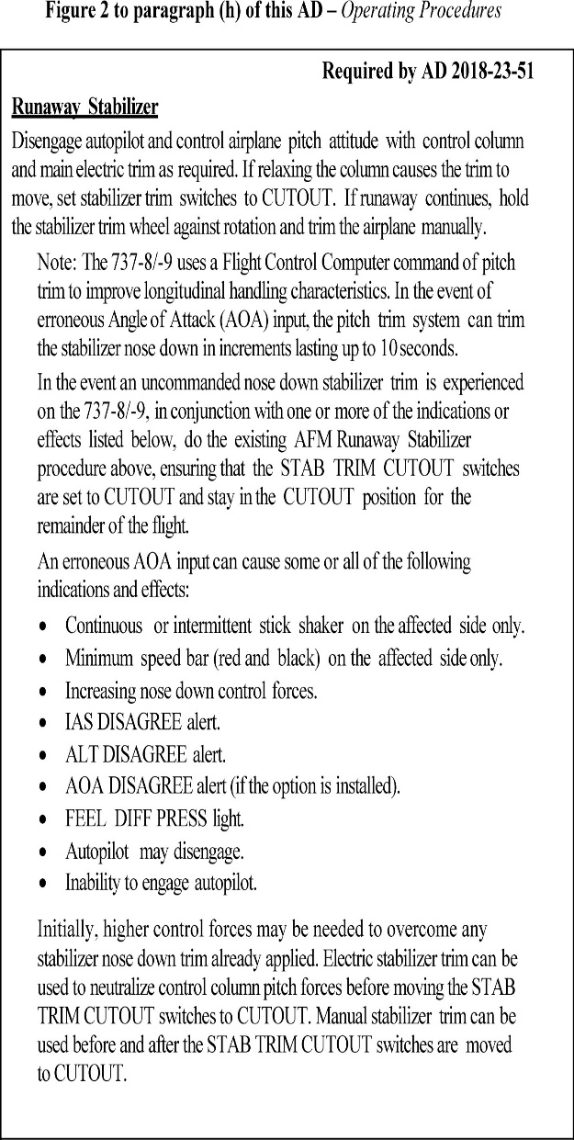

63564
63564 Federal Register / Vol. 83, No. 237 / Tuesday, December 11, 2018 / Rules and Regulations

(i) Alternative Methods of Compliance (AMOCs)
- The Manager, Seattle ACO Branch, FAA, has the authority to approve AMOCs for this AD, if requested using the procedures found in 14 CFR 39.19. In accordance with 14 CFR 39.19, send your request to your principal inspector or local Flight Standards District Office, as appropriate. If sending information directly to the manager of the certification office, send it to the attention of the person identified in paragraph (j) of this AD. Information may be emailed to: 9-ANM- Seattle-ACO-AMOC-Requests@faa.gov.
- Before using any approved AMOC, notify your appropriate principal inspector, or lacking a principal inspector, the manager of the local flight standards district office/ certificate holding district office.
ER11DE18.005</GPH>

(j) Related Information
For more information about this AD, contact Douglas Tsuji, Senior Aerospace Engineer, Systems and Equipment Section, FAA, Seattle ACO Branch, 2200 South 216th St., Des Moines, WA 98198; phone and fax: 206–231–3548; email: Douglas.Tsuji@faa.gov.
(k) Material Incorporated by Reference None.
DSK3GDR082PROD with RULES

63565
Federal Register /Vol. 83, No. 237 /Tuesday, December 11, 2018 /Rules and Regulations 63565
Issued in Des Moines, Washington, on
November 21, 2018.

Issued in Des Moines, Washington, on November 21, 2018.
Michael Kaszycki, Acting Director, System Oversight Division, Aircraft Certification Service.
[FR Doc. R1–2018–26365 Filed 12–7–18; 2:00 pm]
BILLING CODE 1301–00–C

DEPARTMENT OF TRANSPORTATION
Federal Aviation Administration
14 CFR Part 39
[Docket No. FAA–2018–0796; Product
Identifier 2018–NM–104–AD; Amendment
39–19518; AD 2018–25–07]
RIN 2120–AA64
Airworthiness Directives; Bombardier, Inc., Airplanes
AGENCY: Federal Aviation
Administration (FAA), Department of Transportation (DOT).
ACTION: Final rule.

SUMMARY: We are adopting a new airworthiness directive (AD) for certain Bombardier, Inc., Model BD–700–1A10 and BD–700–1A11 airplanes. This AD was prompted by reports of drainage holes on the belly fairing forward and middle access panels being obstructed with sealant. This AD requires inspecting for and removing all sealant blocking the drainage holes on the belly fairing forward and middle access panels. We are issuing this AD to address the unsafe condition on these products.
DATES: This AD is effective January 15, 2019.
The Director of the Federal Register approved the incorporation by reference of certain publications listed in this AD as of January 15, 2019.
ADDRESSES: For service information identified in this final rule, contact Bombardier, Inc., 400 Coˆte Vertu Road West, Dorval, Que´bec H4S 1Y9, Canada; telephone 514–855–5000; fax 514–855– 7401; email thd.crj@ aero.bombardier.com; internet http:// www.bombardier.com. You may view this service information at the FAA, Transport Standards Branch, 2200 South 216th St., Des Moines, WA. For information on the availability of this material at the FAA, call 206–231–3195. It is also available on the internet at http://www.regulations.gov by searching for and locating Docket No. FAA–2018– 0796.
Examining the AD Docket
You may examine the AD docket on the internet at http:// www.regulations.gov by searching for and locating Docket No. FAA–2018– 0796; or in person at Docket Operations between 9 a.m. and 5 p.m., Monday through Friday, except Federal holidays. The AD docket contains this final rule, the regulatory evaluation, any comments received, and other information. The address for Docket Operations (phone: 800–647–5527) is
U.S. Department of Transportation,
Docket Operations, M–30, West
Building Ground Floor, Room W12–140, 1200 New Jersey Avenue SE, Washington, DC 20590.
FOR FURTHER INFORMATION CONTACT: Darren Gassetto, Aerospace Engineer,
Mechanical Systems and Administrative
Services Section, FAA, New York ACO
Branch, 1600 Stewart Avenue, Suite
410, Westbury, NY 11590; telephone 516–228–7323; fax 516–794–5531; email 9-avs-nyaco-cos@faa.gov.
SUPPLEMENTARY INFORMATION:
Discussion
We issued a notice of proposed rulemaking (NPRM) to amend 14 CFR part 39 by adding an AD that would apply to certain Bombardier, Inc., Model BD–700–1A10 and BD–700–1A11 airplanes. The NPRM published in the Federal Register on September 18, 2018 (83 FR 47113). The NPRM was prompted by reports of drainage holes on the belly fairing forward and middle access panels being obstructed with sealant. The NPRM proposed to require inspecting for and removing all sealant blocking the drainage holes on the belly fairing forward and middle access panels.
We are issuing this AD to address fluid leakage that could lead to the accumulation of flammable fluids/ vapors, beyond the design capacity of the belly fairing venting provisions, which could ignite if an ignition source
(i.e., spark, static discharge, heat, etc.) is present.
Transport Canada Civil Aviation (TCCA), which is the aviation authority for Canada, has issued Canadian Airworthiness Directive CF–2018–14, dated May 1, 2018 (referred to after this as the Mandatory Continuing Airworthiness Information, or ‘‘the MCAI’’), to correct an unsafe condition for certain Bombardier, Inc., Model BD– 700–1A10 and BD–700–1A11 airplanes. The MCAI states:
Bombardier Aerospace (BA) has informed Transport Canada that the drainage holes on the belly fairing forward and middle access panels may be obstructed with sealant. The purpose of the drainage holes is to allow for drainage of a limited quantity of fluids due to any leaks, should they occur. This condition, if not corrected, may prevent the
Frm 00007
timely detection of fluid leakage that could lead to the accumulation of flammable fluids/ vapors, beyond the design capacity of the belly fairing venting provisions [which could ignite if an ignition source (i.e., spark, static discharge, heat, etc.) is present].
This [Canadian] AD is issued to mandate the removal of all sealant blocking the drainage holes on the belly fairing forward and middle access panels.
You may examine the MCAI in the AD docket on the internet at http:// www.regulations.gov by searching for and locating Docket No. FAA–2018– 0796.
Comments
We gave the public the opportunity to participate in developing this final rule. We received no comments on the NPRM or on the determination of the cost to the public.
Conclusion
We reviewed the relevant data and determined that air safety and the public interest require adopting this
final rule as proposed, except for minor editorial changes. We have determined that these minor changes:
Are consistent with the intent that was proposed in the NPRM for addressing the unsafe condition; and
Do not add any additional burden upon the public than was already proposed in the NPRM.
Related Service Information Under 1 CFR Part 51
Bombardier has issued the following service information for Bombardier Model BD–700–1A10 airplanes. • Service Bulletin 700–53–051, dated May 17, 2017.
Service Bulletin 700–53–6009, dated May 17, 2017.
Bombardier has issued the following service information for Bombardier Model BD–700–1A11 airplanes.
Service Bulletin 700–1A11–53–026, dated May 17, 2017.
Service Bulletin 700–53–5010, dated May 17, 2017.
This service information describes procedures for inspecting for and removing sealant blocking the drainage holes on the belly fairing forward and middle access panels. These documents are distinct since they apply to different airplane models and configurations. This service information is reasonably available because the interested parties have access to it through their normal course of business or by the means identified in the ADDRESSES section.
Costs of Compliance
We estimate that this AD affects 376 airplanes of U.S. registry. We estimate

